MEDWAY and SWALE BOATING ASSOCIATION

MEDWAY DINGHY REGATTA 2 & 3 July 2016
SPONSORED BY M.T.S. CLEANSING SERVICES (AS LEAD SPONSOR) AND CO-SPONSORED BY PIRATES CAVE, HYDE SAILS and ALLEN Brothers.

Name of event: Medway Dinghy Regatta – 2016
Inclusive dates: Saturday 2 and Sunday 3 July 2016
Organising authority: The Regatta Organising Committee of the Wilsonian Sailing Club (WSC), Main Rd, Hoo, Kent ME3 9HF

SAILING INSTRUCTIONS

1. RULES
  - This event will be governed by the rules as defined in the current Racing Rules of Sailing (RRS).
  - Competitors shall complete the entry form and pay the necessary fee in order to be eligible to race.
1.3 General Recall
When a Class has a General Recall the First Substitute will be displayed, with two sound signals, for up to four minutes, when it will be removed without a sound signal. The start of the recalled Class will be five minutes after the last valid Class start in the sequence (end of queue). If more than one Class in the sequence has a General Recall, then the recalled Classes will start in their original sequence. This changes RRS 29.2
Personal Flotation Devices
Whilst afloat competitors shall wear personal flotation devices, except briefly while changing or adjusting clothing or personal equipment. Wet suits and dry suits are not personal flotation devices. This changes RRS 40.

1.4 Boats shall be sailed using their own class sail number, unless prior consent has been obtained from the organising authority.
1.5 This event is held on a navigable river and ships or other large vessels have right of way. If a ship/vessel is being escorted, no competitor shall sail between the guard boat displaying a naval numeral “zero” and the ship/vessel it is escorting. Any competitor passing between the guard boat and escorted ship/vessel or otherwise impeding the ship SHALL be disqualified without a hearing.
1.6 All entrants will be issued with 2 sets of adhesive boat identification numbers (Bow numbers), which shall be attached as described in 18.4. (example photo’s are displayed on the Official Notice Board)

2. NOTICES TO COMPETITORS
  - Notices to competitors will be posted on the Official Notice Board, which is located on the landward side of WSC race box which is at the top of the downstream slipway.

3. CHANGES TO SAILING INSTRUCTIONS
  - Any change(s) to these instructions will be posted on the Official Notice Board, before the warning signal for any race that it affects.

4. SIGNALS MADE ASHORE
  - Signals made ashore will be displayed at the WSC race box.
4.2 Flag boards, corresponding to the equivalent flag, may be displayed at the race box in lieu of flags.
4.3 Flag A with two sound signals (one when lowered) means “No boat shall go afloat until this signal is lowered. The first warning signal will be made not less than 20 minutes after flag A is lowered”.

5. SCHEDULE OF SERIES
5.1 Race Day Date First Warning Signal
1 Saturday 2/07/16 10:55
2 Saturday 2/07/16 13:55
3 Sunday 3/07/16 09:55
4 Sunday 3/07/16 12.55

6. CLASSES, CLASS FLAGS AND STARTING ORDER

6.1 The Classes are as follows :

Fast Handicap – PY Nos equal to or less than 982
Medium Handicap and Blaze – PY Nos 983 to 1135 inclusive
Wayfarer
2000 class
Slow Handicap and Streaker – PY Nos 1136 to 1385 inclusive
Junior - PY Nos equal to or less than 1385.
(Junior fleet is open to those under the age of 18 years on 3 July 2016. Juniors may opt to sail in an appropriate fleet.)

A boat shall sail in a fleet appropriate to its PY number or class.

6.2 The schedule of classes, their class flags and starting order on Saturday is –

Fleet Class Flag Warning Signal (am) Warning Signal (pm)
Fast handicap “K” 10.55 (Sun 9.55) 13.55 (Sun 12.55)
Medium handicap &
Blaze “T” 11.00 (Sun 10.00) 14.00 (Sun 13.00)
Wayfarer “W” 11.05 (Sun 10.05) 14.05 (Sun 13.05)
2000 “2000” 11.10 (Sun 10.10) 14.10 (Sun 13.10)
Slow handicap &
Streaker “F” 11.15 (Sun 10.15) 14.15 (Sun 13.15)
Junior “V” 11.20 (Sun 10.20) 14.20 (Sun 13.20)
(photo’s of the “flag” layout and start line are displayed on the Official Notice Board)

7. RACING AREAS
  - The chart in Attachment 1 shows the race area.

8. COURSES
8.1 The course to be sailed is allocated by number(s), which refer to the Medway Dinghy Regatta Course Sheet, Attachment 2; the course number(s) for each Class and race will be displayed on the Official Notice Board at or before the warning signal for each race.

9. MARKS
9.1 The marks of the course, will be made up from some or all of the following:
A) Fixed Position navigation buoys, Green coloured odd numbered, Red coloured even numbered, Hoo Creek Bouys No. 1(Green) & 2(Red) and South Yantlet Creek No.4 (Red & White Safe Water) buoy.
B) Fixed position racing marks numbered MYA1 and “Autumn” (all orange/yellow cylindrical marks floating horizontally)
C) Club Buoys orange/yellow coloured numbered 1, 2, 3 and 4 or mark boats displaying flag “M” .
D) Long Reach Buoy “PA 3” (A orange/yellow Police Mooring Buoy between “Autumn” and MYC4)
E) Additional marks as identified on the course board may be used.

10. AREAS THAT ARE OBSTRUCTIONS
10.1 Folly Point and Darnett Fort beacons are obstructions and illustrative photo’s are displayed on the Official Notice Board. Folly Point shall be passed to the South and Darnett Fort beacon shall be passed to the North.

11. THE START
11.1 Races will be started using RRS 26 with the warning signal given 5 minutes before the starting signal of each race.
11.2 The starting line will be the Wilsonian Sailing Club line, which is an extension of an imaginary line through the two white posts with triangular top marks, one of which is behind and one in front of the Race Box (see Attachment 1). The Outer Distance Mark (ODM) may not be positioned on, and should not be considered part of the aforementioned “imaginary line”. The line length is limited by the ODM which must be passed to the North – that is between ODM and Race Box. The starting line may be used in either an upstream or downstream direction depending on the course set for each race.
11.3 Boats whose preparatory signal has not been made SHALL keep clear of the starting area and of all boats whose preparatory signal has been made.(Rule 24.1)
11.4 A boat starting later than 4 minutes after her starting signal will be recorded as Did Not Start. This changes RRS A4 and A5.

12. THE FINISH
  - The finish line description and use is as the starting line, see 11.2.

13. TIME LIMITS
13.1 a) To apply to the first boat in a class and not the first boat to finish.
b) Time limits. All elapsed times from class start
Race 1 Race 2 Race 3 Race 4

1½ hours 3 hours 1½ hours 1½ hours
c) If this time is not met then all boats “Checked-Out” in that Class in accordance with Sailing Instruction 18.1 shall score as “DNF”. If the first boat time limit is met, “Checked-Out” boats in that Class not finishing within 30 minutes of the Time Limit will be scored “DNF”. This Changes Rule 35

14. The RYA Portsmouth Yardstick handicap system will be used.

15. SHORTENED COURSES
15.1 When a course is being shortened at the starting/finishing line and to indicate the class/es is/are being finished in a downstream direction, a Red flag board will be displayed with flag S. This is only applicable to courses with a mark positioned upstream of the start/finish line.
15.2 When flags S and C are displayed at a rounding mark the shortened course shall be between the rounding mark and boat displaying the flags directly back via the main channel to finish at the Wilsonian Sailing Club line. No boat shall pass through Hoo Creek.
15.3 Boats shall pass within 3 boat lengths of the mark at which the course is shortened (not applicable in respect of 15.1 above).

16. PROTESTS
16.1 Protest forms are available at the Race Office and completed forms shall be delivered there within 45 minutes of the last boat’s finish time in that race, unless the Protest Committee sees good reason to extend this time limit. Last boat’s finishing times will be displayed on the Official Notice Board.
16.2 Protests will be heard in an order decided by the Protest Committee which shall be displayed on the official Notice Board and heard and as soon as practicable.

17. SCORING
17.1 Race results will be calculated using each boat’s corrected time.
17.2 When 3 or fewer races have been completed, a boats series score will be the total of her race scores.
17.3 When 4 races have been completed, a boat’s series score will be the total of her race scores excluding her worst score.

18. SAFETY REGULATIONS

18.1 Participants must Check-Out before racing, by taking their SAFETY TAG, one per person e.g. helm and crew, from the “Safety Boards” which are located in the downstream safety boat shed and carrying it on their person at all times whilst afloat. Boats whose crews have not Checked-Out shall be scored “Did Not Come To the Starting Area” (DNC).
18.2 Participants must Check-In by returning their SAFETY TAG(s) to the “Safety Boards” located in the down-stream safety boat shed within 20 minutes of their finishing time. Boats whose crews have not returned their Safety Tag(s) within this time limit shall be scored “Disqualified” (DSQ). This time limit may be extended at the discretion of the organising authority.
18.3 At the same time as Checking-In all boats must declare their status on the declaration form located with the “Safety Boards” e.g. completed the race and “Finished”, “Did Not Start”, “Did Not Finish” or “Retired After Finishing” as applicable.
18.4 All boats will have a Boat Identification Number (Bow Number), which shall correspond with the boat’s Entry Number and helm’s and crew’s Safety Tag Number. Each boat will be issued with two sets of Bow Numbers at registration. These panels shall be placed as high as possible on the hull each side of the bow forward of the mast. (example photo’s are displayed on the official notice board) Boats may, at the discretion of the race committee, be disqualified from any race during which its Bow Number is not correctly displayed if the Race Committee feels that not enough care was exercised in fixing panels/numbers or prompt action was not taken to replace numbers. This changes RRS 63.

19. EQUIPMENT AND MEASUREMENT CHECKS
19.1 A boat or equipment may be inspected at any time for compliance with the class rules and sailing instructions.

20. OFFICIAL BOATS
20.1 It is intended that craft engaged upon race management will display international code flag numeral “nine”. There will be no grounds for redress if this is not adhered to.

21. RADIO COMMUNICATION
21.1 Except in an emergency a boat shall neither make radio transmissions while racing nor receive radio communications not available to all boats. This restriction includes cellular telephones.

22. PRIZES
22.1 There will be a prize giving at the Wilsonian Sailing Club on Sunday 3 July, as soon as practicable after completion of the race results.
22.2 Prizes will be awarded as follows:
A Perpetual Trophy for Class Winners
Keepsake Glassware for Class Positions as determined by the Organising Authority.
Wine or appropriate prize for Race Winners

23. RISK STATEMENT
Rule 4 of the RRS states “The Responsibility for a boat’s decision to participate in a race or continue racing is hers alone.”
Sailing is by its nature an unpredictable sport and therefore inherently involves an element of risk. By taking part in the event, each competitor agrees and acknowledges that:
a) They are aware of the inherent element of risk involved in the sport and accept responsibility for the exposure of themselves, their crew and their boat to such inherent risk while taking part in the event;
b) They are responsible for the safety of themselves, their crew, their boat and their other property whether afloat or ashore;
c) They accept responsibility for any injury, damage or loss to the extent caused by their own actions or omissions;
d) Their boat is in good order, equipped to sail in the event and they are fit to participate;
e) The provision of a race management team, patrol boats and other officials and volunteers by the event organiser does not relieve them of their own responsibilities;
f) The provision of patrol boat cover is limited to such assistance, particularly in extreme weather conditions, as can practically be provided in the circumstances.

24. INSURANCE
  - 24.1 Each participating boat shall be insured with adequate valid third-party liability insurance.

Attachment 1

Chart of Race Area

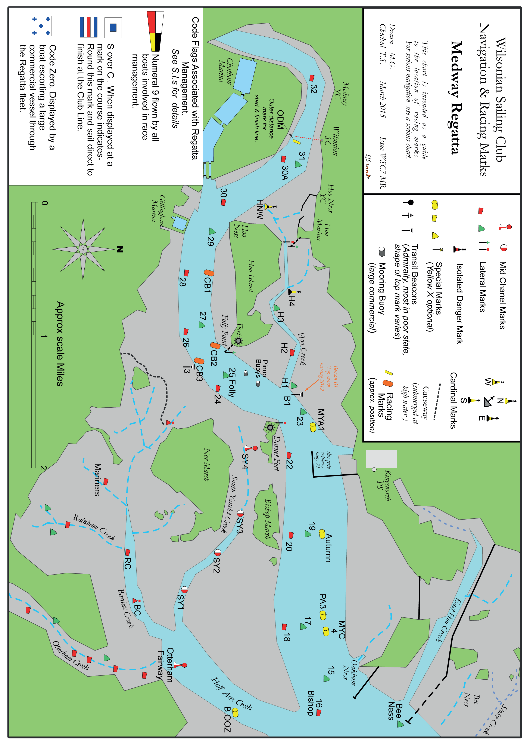

Attachment 2

Medway Dinghy Regatta Course Sheet

No. | Course | Miles
1 | 30P, 26P, SY4P, 23S, 22P, AutS, 20P, PA3P, 22P, 24S, 26S, CB2P, 30S, 31P, LINE | 10.0
2 | 30P, 25P, 23S, 22P, PA3S, 20S, 22P, 24S, 26S, CB2P, 30S, 31P, LINE | 8.8
3 | 30P, 25P, 22P, MYA1P, 26P, SY4P, 27S, 30S, 31P, LINE | 8.0
4 | 30P, 25P, 23S, 27S, 23S, 27S, 30S, 31P, LINE | 7.2
5 | 30P, 25P, 22P, MYA1P, 26S, 30S, 31P, LINE | 6.1
6 | 30P, 25P, 23S, 27S, 30S, 31P, LINE | 5.2
7 | 30P, 26P, 25S, CB3S, 27S, CB2P, 30S, 31P, LINE | 4.6
8 | 30P ,28P, 27S, 26S, 30S, 31P, LINE | 3.3
9 | 30P, 28P, CB1P, 30S, 31P, LINE | 2.6
10 | 30P, 26P, CB1S,SY4P, 29P,CB3P,CB2P, 30S, 31P,LINE | 7.8
11 | 30P, 26P, 29S, CB3P, CB2P, 29RS, 26P, 27P, 30S, 31P, LINE | 6.5
12 | 29P, 26P, H2S, SY4P, H1S, 20P, MYA1P, 24S, 30S, 31P, LINE | 8.5
13 | 29P, 27P, 23S, 20P, AUTS, 18S, MYA1P, 27S, 30S, 31P, LINE | 8.7
14 | 29P, 26P, H2S, SY4P, 23S, 22P, MYAIP, 24S, 30S, 31P, LINE | 7.5
15 | 29P, 25P, 23S, 27S, 30P, 27P, 25P, 30S, 31P,LINE | 7.5
16 | 29P, 26P, H2S, SY4P H1P, 27S, 30S, 31P, LINE | 6.1
17 | 29P, 27P, 23S, 25S, 29S, 30S, 31P, LINE | 5.3
18 | 29P, CB2S, CB3P, 25S, 24S, 27P, 26S, 30S, 31P, LINE | 4.7
19 | 29S, 28P, 27S, 26S, 30S, 31P, LINE | 3.2
20 | 29S, 28P, CB2RS, 30S, 31P, LINE | 3.7
21 | 29P, CB2S, CB3S,30S, SY4S, 29P, 27S, 30S, 31P, LINE | 8.8
22 | 30P, CB2S, CB3S, 30S, CB2S,29P, CB3S,30S,31P, LINE | 8.7
23 | 30P, 25P, AUTP, 26P, SY4P, H1P, 27S, 30S,31P, LINE | 9.5
24 | 30P, 25P, 22S, PA3S, 22P, 25S, 30S, 31P, LINE | 8.4
25 | 30P, 25P, 23S, 22S, 26P, SY4P, H1P, 27S, 30S, 31P, LINE | 8.3
26 | 30P, 25S, 27S, 23S, 27S, 23S, 25S, 30S, 31P, LINE | 8.0
27 | 30P, 25P, 23S, 24P, SY4P, H1P, 27S, 30S,31P, LINE | 6.7
28 | 30P, 25P, 23S, 27P, 25P, 29S, 30S, 31P, LINE | 6.1
29 | 30P, CB2S, 26P, 25S, CB3S, CB2P, 26S, 30S, 31P LINE | 4.9
30 | 30P, CB1S, 29S, 30S, 31P, LINE | 2.5
21 | 30P, 27S, 26S, CB1P, 28S, 30S, 31P, LINE | 3.3
32 | 30P, CB2S, CB3S, 29RP, SY4S, 26S, 27P, CB1P, 30S, 31P, LINE | 7.4
33 | 30P, CB2S, CB3S, 29P, 30S,CB2S, CB3S, 29P,27S, 30S, 31P, LINE | 7.6
34 | 29P, 26P, SY4P, H1S,18P, MYA1P, 25S, 27S, 30S, 31P, LINE | 9.4
35 | 29P, 25P, 23S, 18P, PA3P, 22S, MYA1P, 27S, 30S, 31P, LINE | 8.7
36 | 29P, 26P, SY4P, H1S, 22P, MYA1P, 25P, 22P, MYA1P, 27S, 30S, 31P, LINE | 8.8
37 | 29P, 25P, 23S, 20P, MYA1P, 27S, 29S, 27S, 30S, 31P, LINE | 8.3
38 | 29P, 26P, SY4P, H1P, SY4P, H1P, 27S, 30S, 31P, LINE | 6.5
39 | 29P, 25P, 23S, 20P, MYA1P, 27S, 30S, 31P,LINE | 6.8
40 | 29P, 26P, 27S,24P, 25P, CB3S, CB2P, 30S, 31P, LINE | 4.6
41 | 29P, CB1S, 28S,30S, 31P, LINE | 2.5
42 | 29P, 26P, 27P, 28S, 30S, 31P, LINE | 3.3
43 | 29P, 27P, SY4RP, 26S, CB1P, 30S, CB3P, CB2P, 30S, 31P, LINE | 7.9
44 | 29P, 26P, CB2P, 30S, 27S, CB3P, CB2P, 29P, 27P, 30S, 31P, LINE | 7.4
50a,b etc. | SPECIAL COURSE – SEE OFFICIAL NOTICE BOARD | N/A
N.B. For avoidance of doubt S= starboard, P =port, RS= round to starboard RP = round to port.

